21.35: a)
Yes, ok to neglect 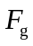 because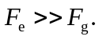
b)
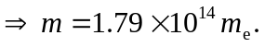
c) No. The field is uniform.

